

Assessment Report

Student name: Mark Beresford

Student Number: 471731221

Unit/Cluster: ICTWEB519_520

Assessment Number: 3



Contents

Title 3

1. Project Requirements (Part 1) 3

Client Requirements 3

Wireframes 3

Styling Information 3

Typography 3

Iconography 3

Colour Scheme 3

Markup Language Comparison 3

2. Test, debug and validate (Part 3) 4

Validation 4

Accessibility Testing 4

Browser/Device Testing 4

Cyber security measures 5

Authentication process 5

Programmatically engineered solutions to avoid cyber-attacks 5

Internet protocols 5

Project Signoff 5

3. Knowledge Questions (Part 4) 5

Appendices 5

References 5

Title

ML Strength – Health and Fitness

Date: 12/05/2023

1. Project Requirements (Part 1)

Client Requirements

* 1. What does the client want to achieve with this web page?

To entice health conscience adults who are looking for something slightly different from a local gym, that doesn’t come on strong with selling gimmicks, and is geared to putting the needs of the customer first.

* 1. Who is the target audience for the page?

Health conscience local adults, who need a gym to be able to fit in around their schedule, and that offer a wide range of classes. Specific areas on offer are weight-loss, boxing and karate.

* 1. Are there any legislative or organisational standards that the designer/developer must comply with in the development of the web page?

|  |  |  |  |
| --- | --- | --- | --- |
| LEGAL OBLIGATION | | ACTIONS REQUIRED | SOURCE |
| Privacy Act | | * Inform your customers of what measures you have in place to protect their personal details, such as names, addresses and credit card details. * Check your privacy policy is compliant with Australian privacy law and is easily accessible on your website. | <https://www.business.qld.gov.au/running-business/digital-business/online-risk-security/legal-obligations> |
| Legal Obligations and jurisdictions | * Assess your online business activities and the geographic areas your business operates within and identify the legal obligations that apply. * Create a plan to ensure that all your business activities comply. * Conduct regular reviews or sign up for updates to make you aware of any changes, or seek professional advice. | | <https://www.business.qld.gov.au/running-business/digital-business/online-risk-security/legal-obligations> |
| Email Marketing | * Comply with the [Spam Act 2003(Cwlth)](https://www.legislation.gov.au/Series/C2004A01214) | | <https://www.legislation.gov.au/Details/C2016C00614> |
| Copyright | * Images and content to meet copyright requirements * Have permissions to use intellectual property | |  |
| Consumer Law | * Online advertising is not false or misleading. * Online reviews are genuine. * Uphold responsibilities to customers. * Comply with Australian Product/Mandatory safety laws | | <https://www.business.qld.gov.au/running-business/digital-business/online-risk-security/legal-obligations> |
| Website term of use | * A terms of use document that includes information on protecting your business ideas, disclaimers and rules applying to anyone who interacts with your website. | | <https://www.business.qld.gov.au/running-business/digital-business/online-risk-security/legal-obligations> |
| Terms and Conditions | * If you sell products online, include terms and conditions outlining the operations of your business sales, payment options, cancellation policies, consumer guarantees, and return and refund policies. * You should also have a process for customer complaints. | | <https://www.business.qld.gov.au/running-business/digital-business/online-risk-security/legal-obligations> |
| Business Information | * Contact details are included and easy to find | | <https://www.business.qld.gov.au/running-business/digital-business/online-risk-security/legal-obligations> |
| Client Agreement | * If you provide services online, include a client agreement. * This should contain information about payment, expectations, termination of the agreement, and the process for handling disputes | | <https://www.business.qld.gov.au/running-business/digital-business/online-risk-security/legal-obligations> |
| Electronic Transactions | * Provide payment mechanisms that are easy to use and give appropriate security. * Clearly explain the security and authentication methods you use so customers can assess any risks | | <https://www.business.qld.gov.au/running-business/digital-business/online-risk-security/legal-obligations> |
| Accessibility Standards | * Comply with WCAG 2.0/2.1 standards * Ensure that WCAG 2.1 success criteria support mobile use-cases * Define a clear conformance model for WCAG 2.1/dot.x releases * Ensure the conformance structure utilizes the WCAG 2.0 A / AA / AAA model | | <https://www.w3.org/TR/WCAG20/>  <https://w3c.github.io/wcag21/requirements/> |

1.8 Wireframes

Desktop home-page

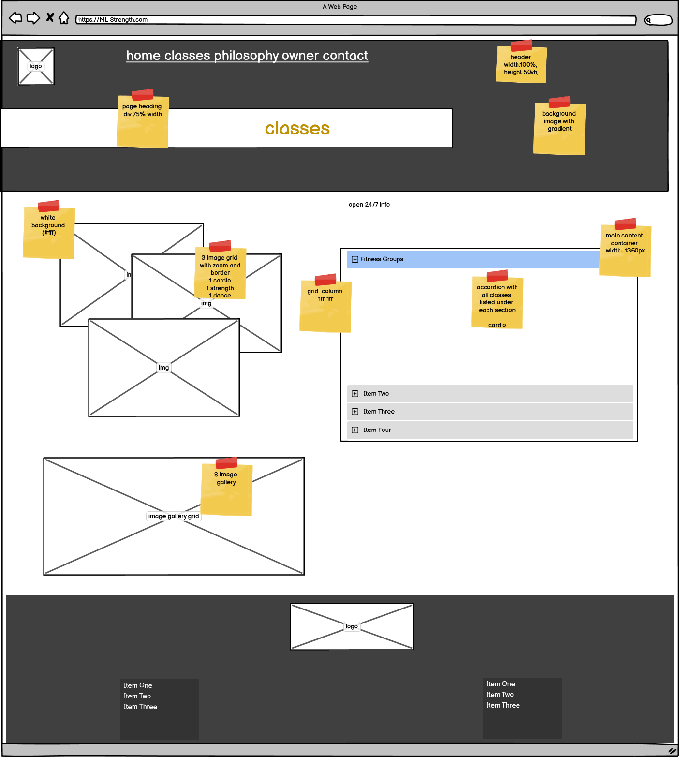

Desktop Classes page

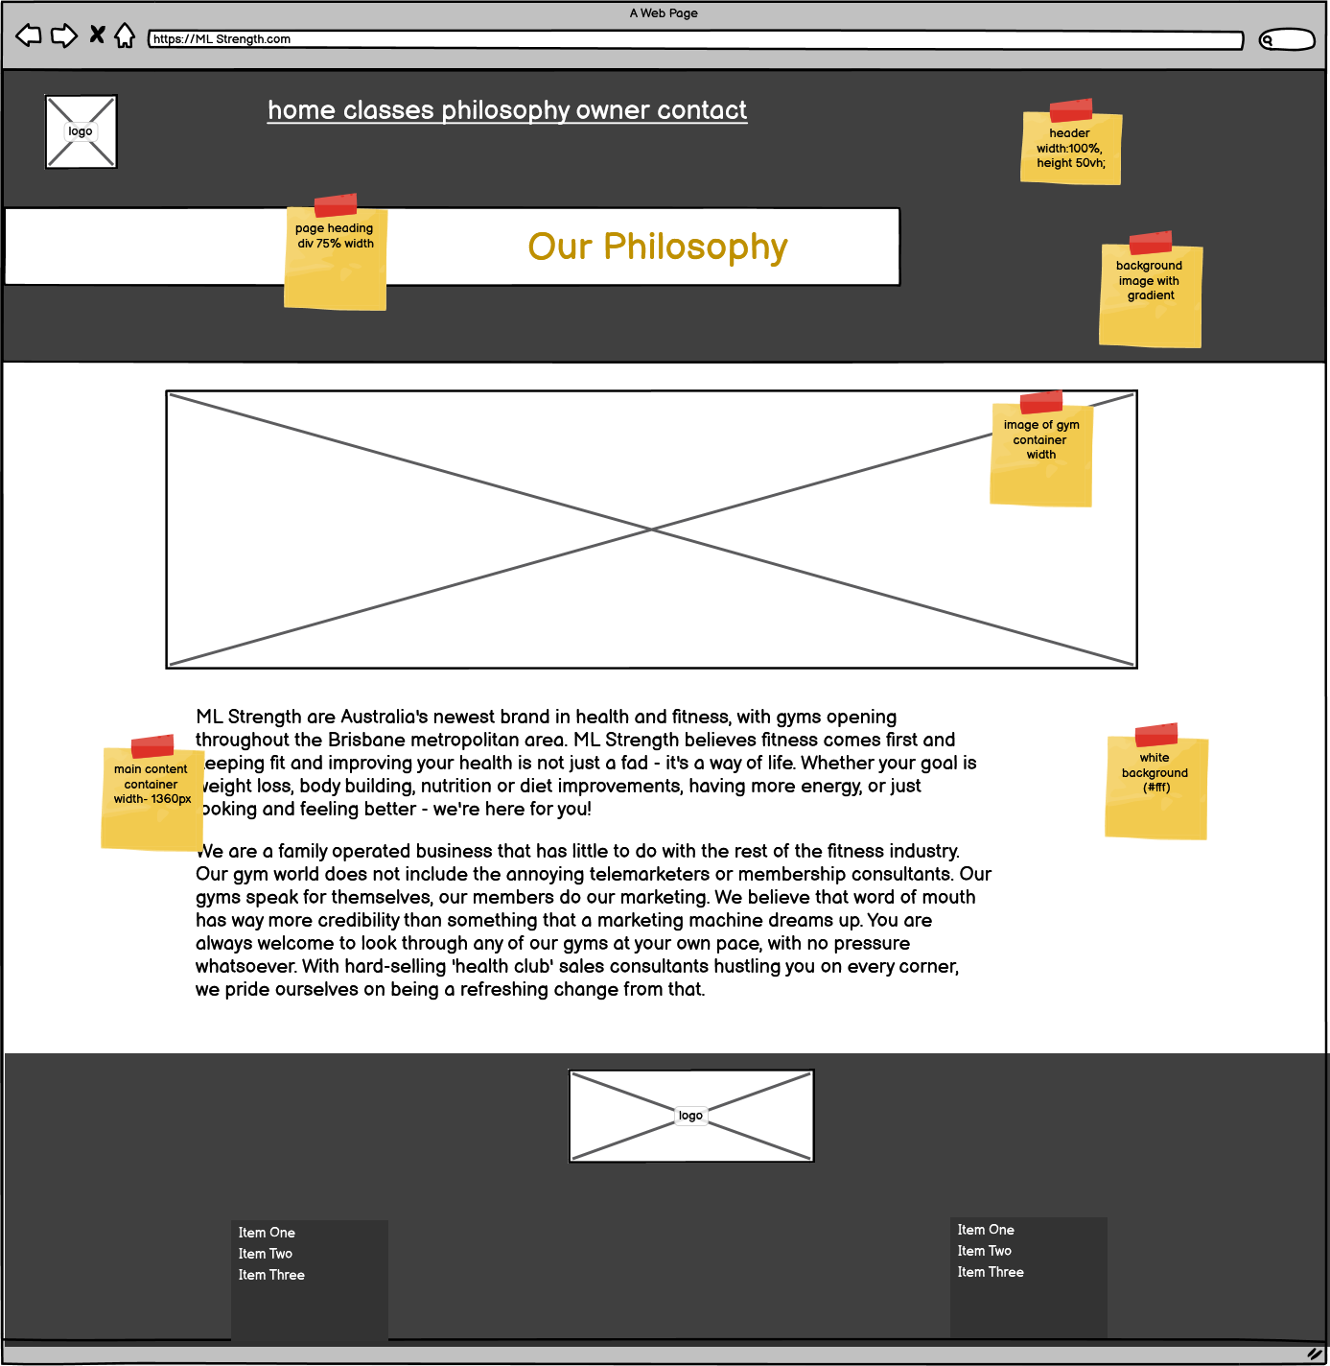

Desktop Philosophy page

Desktop Owner page

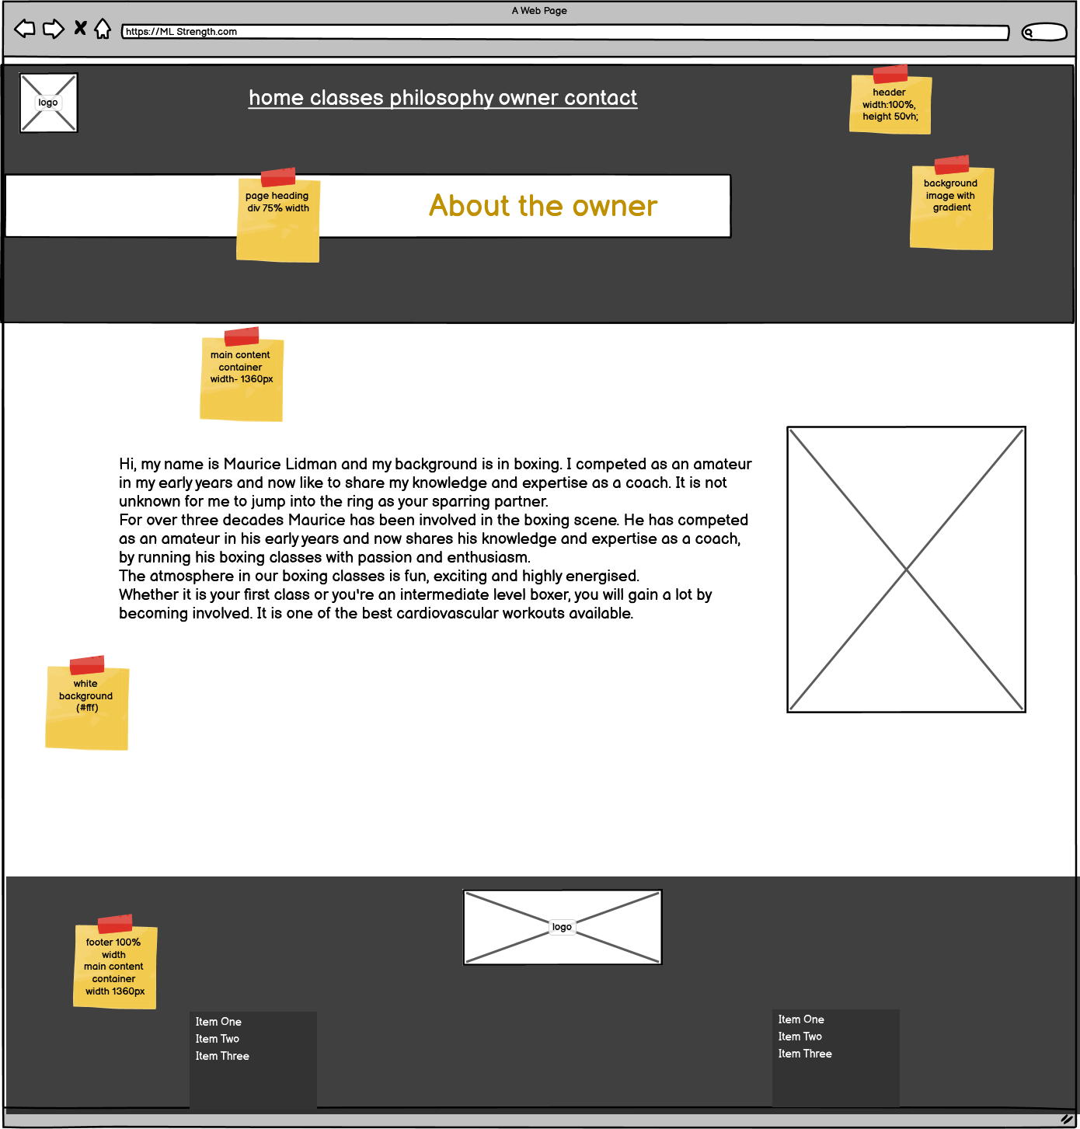

Desktop Contact form page

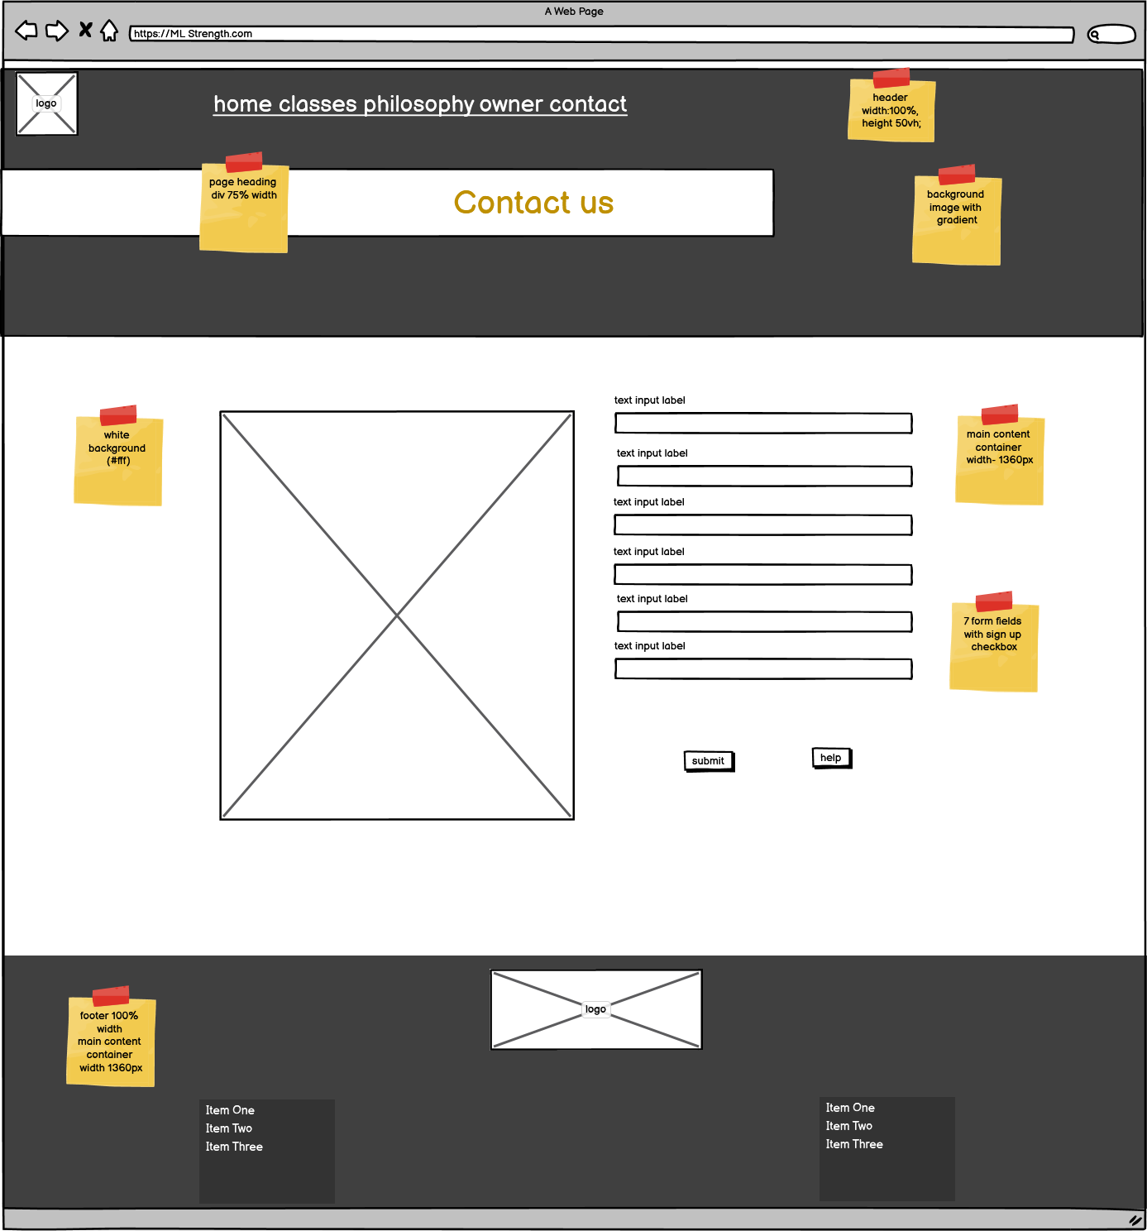

Mobile Index page

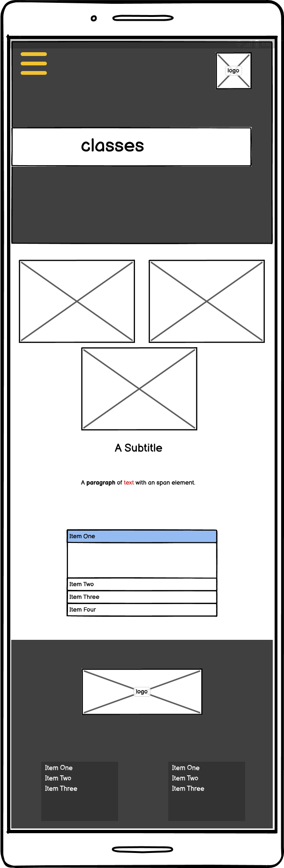

Mobile Classes page

Mobile Philosophy page

Mobile Owner page

Mobile Contact page

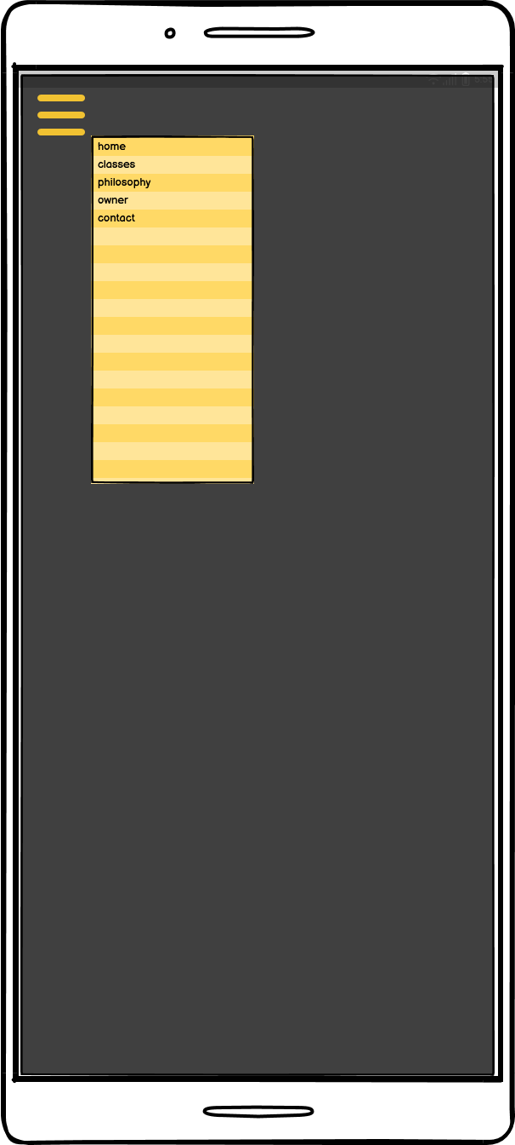

Pop-up Menu page

1.9 Styling Information

Typography

|  |  |
| --- | --- |
| Main Styles | |
| Title/Heading 1 | 60px - 40px |
| Heading 2 | 30px |
| Heading 3 | 25px - 30px |
| Heading 4 | 20px - 25px |
| Link: link, active and hover | 20px |
| Paragraph | 20px |
| Fig caption | 18px/14px/12px |
| Unordered Lists | 16px |
| Font-family | |
| Headings | Palanquin Dark |
| Paragraphs/list | Lato |
| Back-up | Sans serif |

Iconography

The iconography format style I chose is from the font-awesome, as they could be added using CSS content,. These can then be coloured using color in CSS, and sized using font-size in CSS.

Below is listed the specific icons I chose and why:

|  |  |
| --- | --- |
|  | To represent the name in the form field |
|  | To represent the email address in the form field |
|  | To represent the phone number in the form field |

Colour Scheme

|  |  |
| --- | --- |
| **COLOUR SCHEMES** | |
| **PAGE CONTENT** | |
| **Background:**  Header background will be a gradient fading from left to right using #212529  Main page background will be white #fff  Footer background will be set using background color to #0a0b0c. | **Text:**  Headings and text will use a dark grey #212529 except the main title headings and text which will use white #fff as they have a dark background |
| **Buttons/Links:**  Buttons will be set using the secondary colour orange #e8590c.  Nav Links will be white #fff as they are set on a black background.  CTA links will use the secondary colour orange #e8590c.  **Icons:**  Form icons will use the secondary colour orange #e8590c. | **FORMS:**  **Background:**  White background with orange border  **Labels:**  Page Text colour  *required as secondary orange colour  **Input fields:**  Grey background  Placeholder slightly darker grey  **Submit Button:**  Secondary orange colour.  Help link grey background with secondary orange text. |
| **SCHEME**  Colour Palette |
| **White space** | Used for main content only |

2. Test, debug and validate (Part 3)

3.3 Validation

**3.3 HTML Validation Testing**

Index page Test - 1

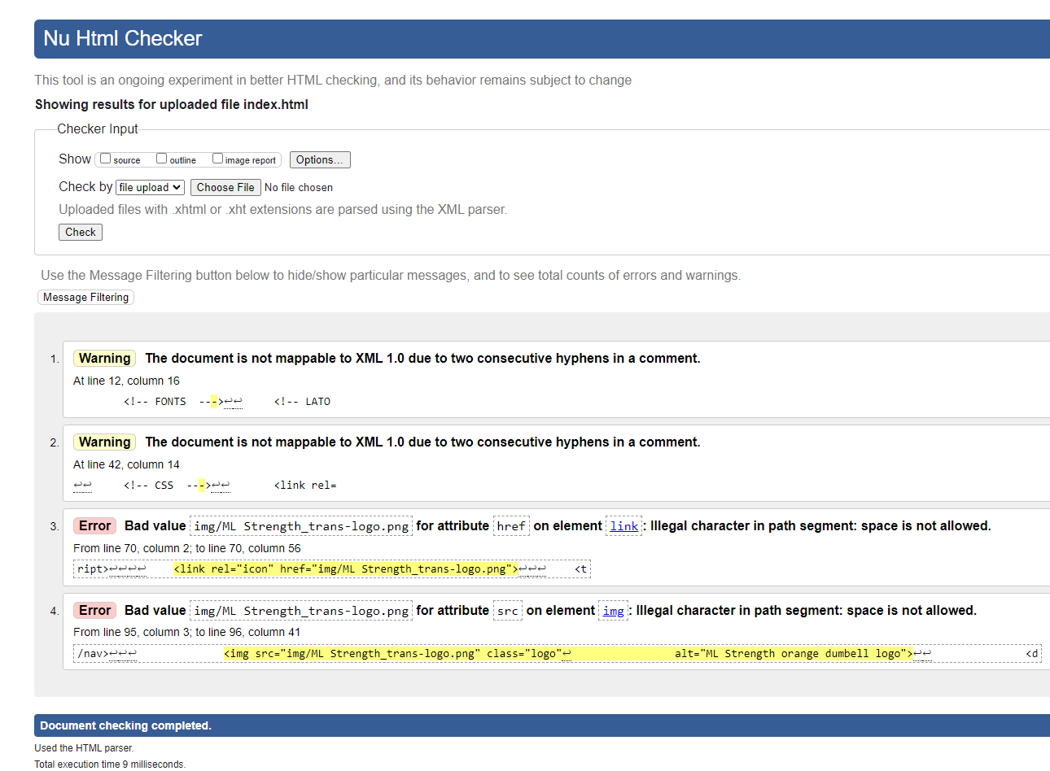

Index Page Test -2

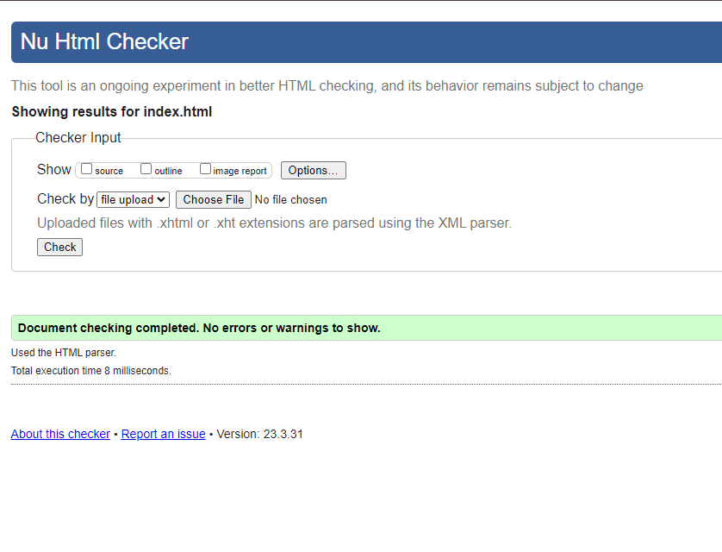

Classes Page Test -1

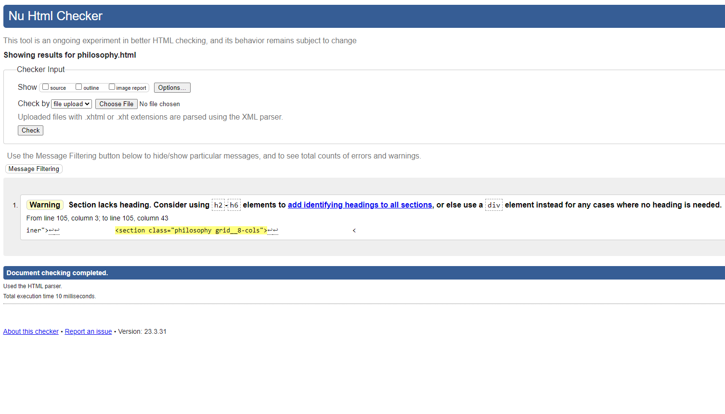Philosophy Page Test -1

Philosophy Page Test-2

Owner Page Test -1

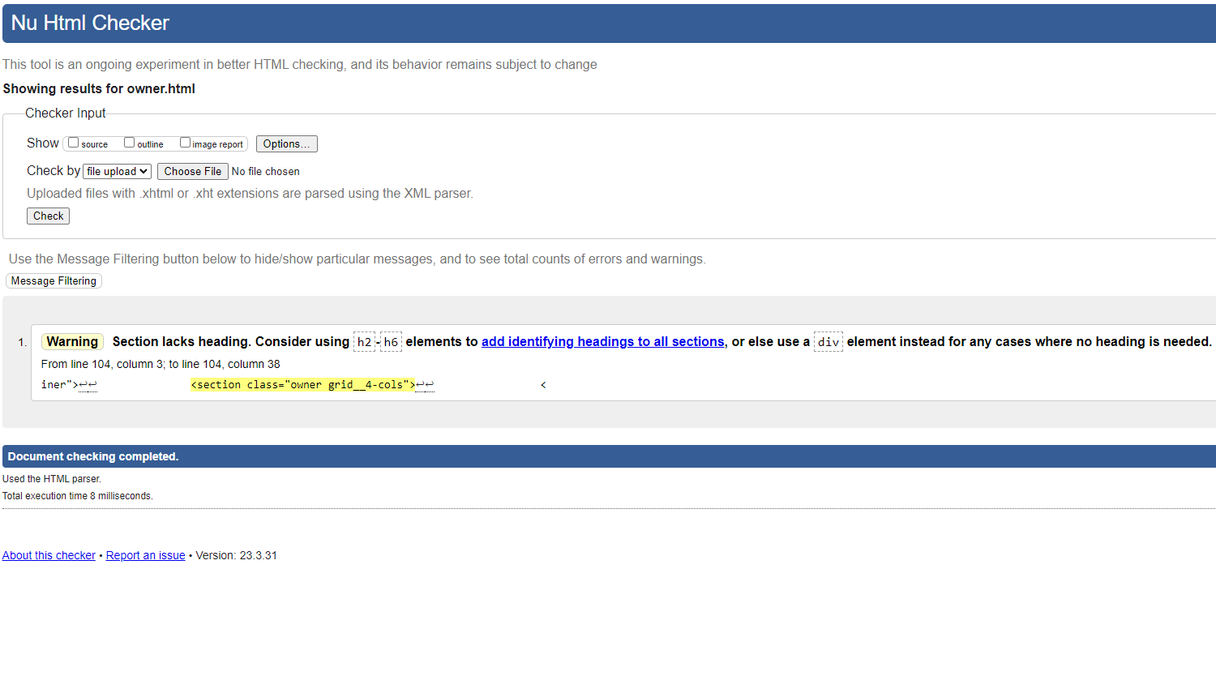

Owner Page Test -2

Contact Page Test -1 Screen 1

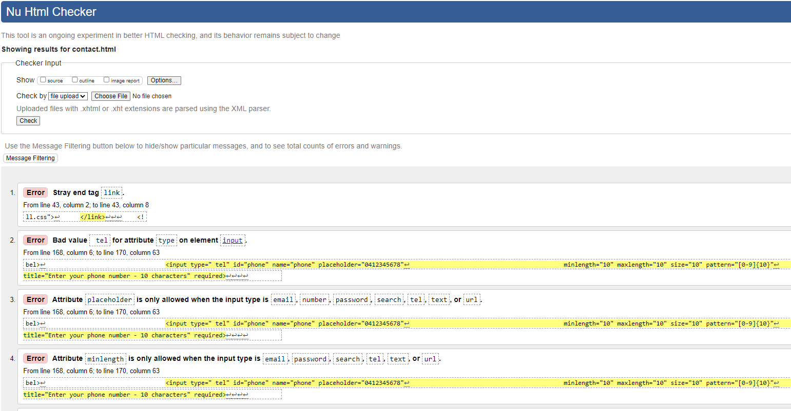

Contact Page Test -1 Screen 2

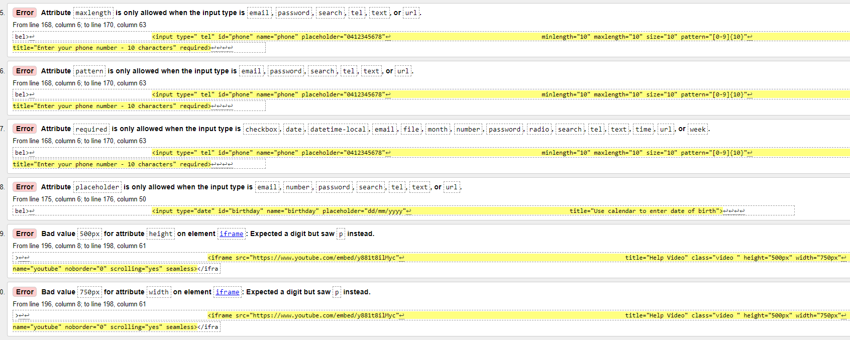

Contact Page Test -1 Screen 3

Contact Page Test -1 Screen 4

Contact Page Test -2

**3.3 CSS Validation Testing**

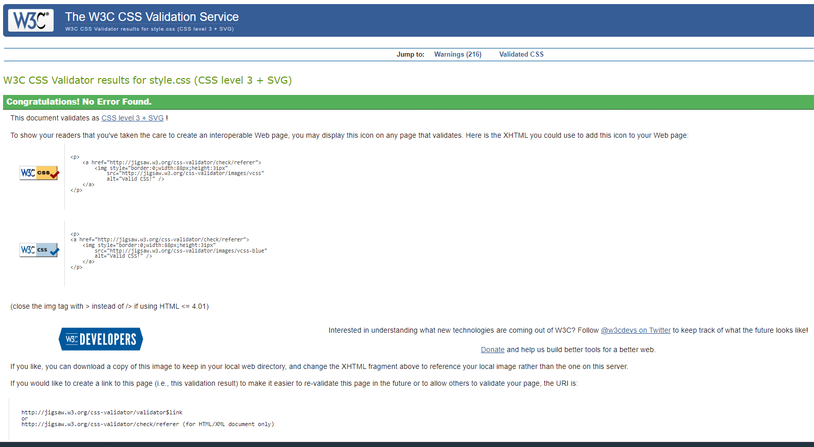style.css Test -1

3.4 Browser/Device Testing

*Include your screenshots here. You should ensure you clearly label each screenshot with the device and browser used for your testing*

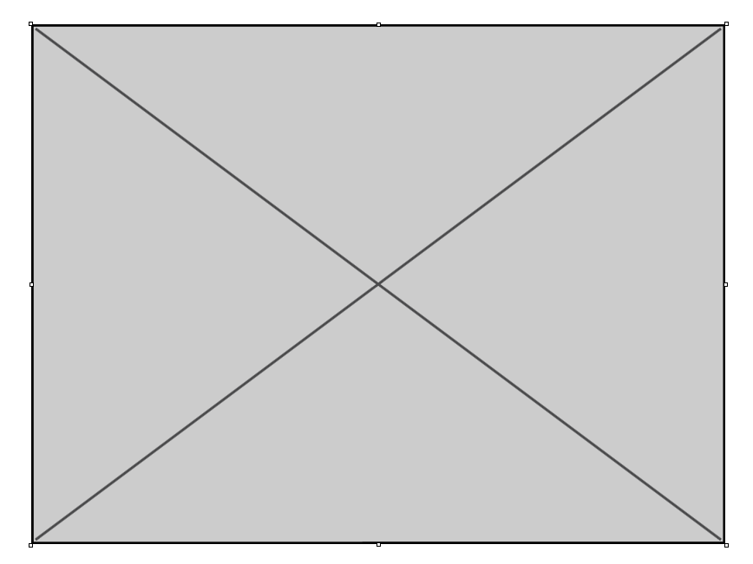

Figure 1 - Desktop PC - Google Chrome

3.5 Autoprefixer

*Run Autoprefixer or similar tool to parse your CSS file and add vendor prefixes to your CSS. Fix as*

*necessary. Re-test. Provide screenshots.*

3.6 Accessibility Testing

*Include screenshots of your first round of accessibility here. If corrections are required you should make the corrections and retest and include the updated screenshots.*

3.7 Cyber security measures

*Include the answers to the cyber security questions here*

Authentication process

Programmatically engineered solutions to avoid cyber-attacks

Internet protocols

Project Signoff

*Copy, paste and complete the project signoff table from the assessment document*

Appendices

*Include any appendices in this section*

References

*Include any references in this section*